# CS 255 System Design Document Template

This template lays out all the different sections that you need to complete for Project Two. Each section has guidance to prompt your thinking. You will need to continually reference the interview transcript as you work to make sure that you are addressing your client’s needs. There is no required length for the final document. Instead the goal is to complete each section based on what your client’s needs are. Remove this note when you are finished, and replace all bracketed text with the relevant information.

## UML Diagrams

### UML Use Case Diagram

### UML Activity Diagrams

*[You were asked to choose* ***two*** *use cases and create* ***two*** *activity diagrams, one for each use case. Please insert* ***both*** *of your activity diagrams here. Check to make sure that you included appropriate components and symbols and that your design meets the client’s needs.]*

### UML Sequence Diagram

### UML Class Diagram

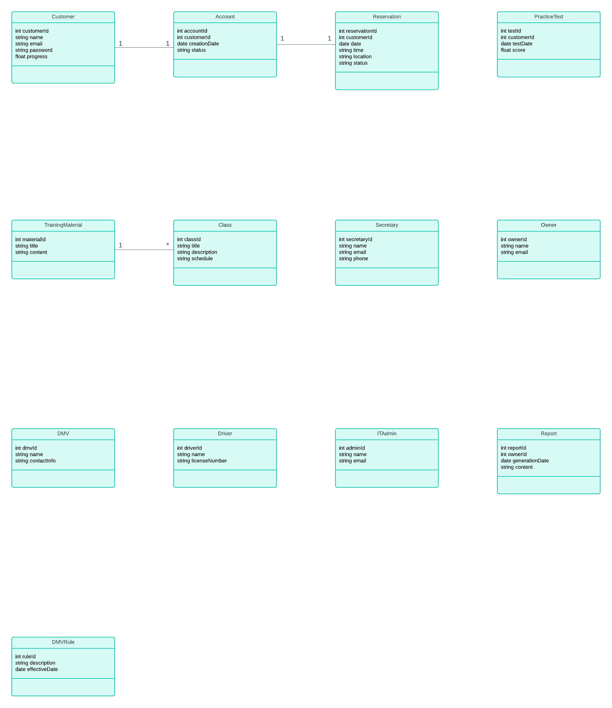

## Technical Requirements

*[Based on the diagrams you have created, describe the technical requirements of your system. These requirements should address the required hardware, software, tools, and infrastructure necessary for your system design.]*

***Hardware and Infrastructure Requirements***

* **Server Infrastructure –** The system will need a dedicated server for application hosting and database storage. This implies that the server will have adequate hardware specifications and the network capabilities to effectively communicate between the host and the clients.
* **Database Server –** Underneath the infrastructure of the server the database server should be configured correctly to store and manage user data. It should also have server backup protocols set up to prevent data loss.
* **Load Balancing –** The infrastructure should handle loading by diverting traffic to other servers. This will allow the system to effectively provide fast response times in times of high traffic volumes.

***Software Requirements***

* **Operating System –** The system should run on a proper server operating system, like Linux or Window server. This also ensures that security and feature-ability is always up to date.
* **Database Management System** – The system should employ a DBMS that can store and manage data.
* **Web Server –** The system should employ a web server to handle HTTP requests.
* **Web Stack –** On top of using a web server, the system should implement a full web stack to support the scalability of the project, as it is allowing for multiple system to utilize

***Tooling Requirements***

* **Version Control –** When creating a large-scale project, system versions need to be controlled and enforced. This will allow for code integrity and collaboration.